It's Time to Renew Your Membership!
Current SWOAFP contact who wants to become a member:
- Click the Login button in the top left-hand side of the page

- Enter your email address and password
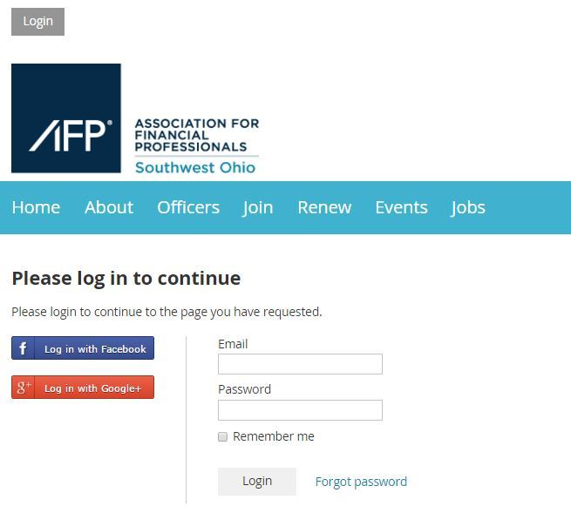

- Click on your name in the top left-hand side of the page
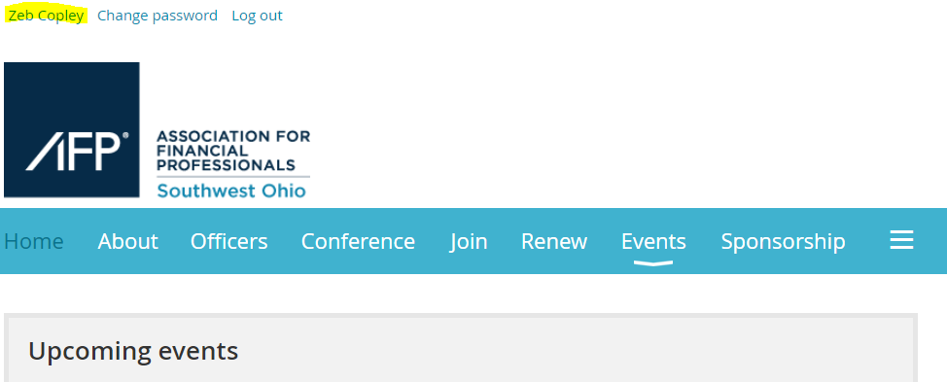

- Click the button next to your Membership Level that says “Change”
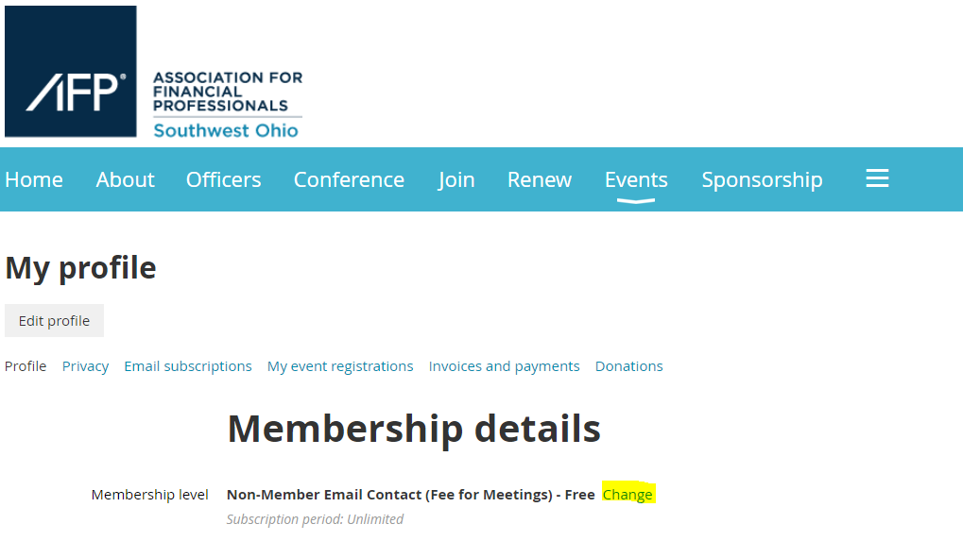

- Select the Membership Level you would like for 2021 and click “Next” in the bottom right hand corner.
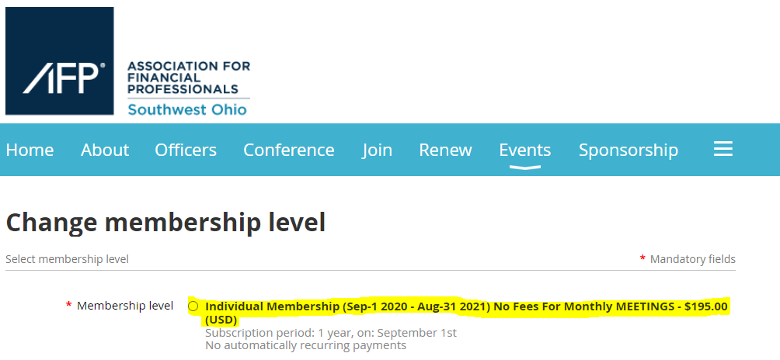
- Follow the prompts to update your contact information and submit your payment.

