It's Time to Renew Your Membership!
Not a Member? Click here to join!
Current Member? See below:
- Click the Login button in the top left-hand side of the page

- Enter your email address and password
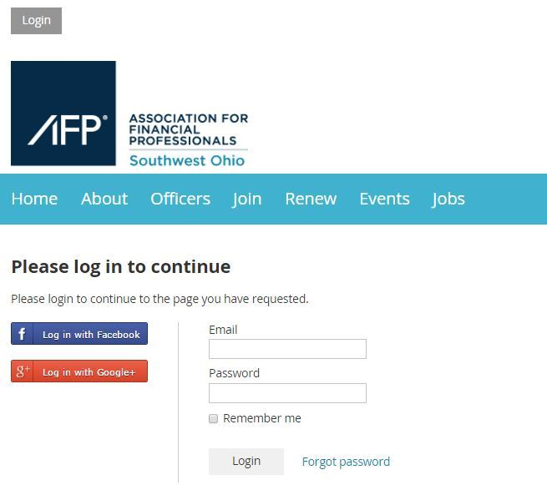
- Click on your name in the top left-hand side of the page
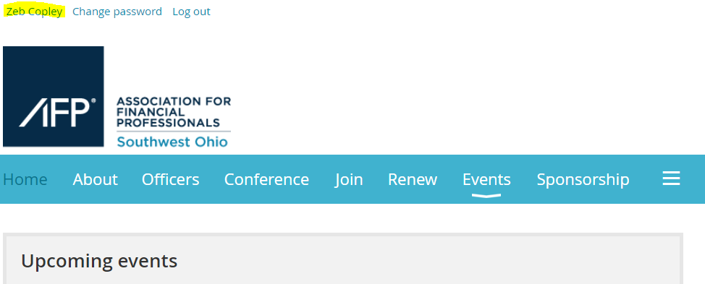

- Click the button next to your Membership Level that says “Change”
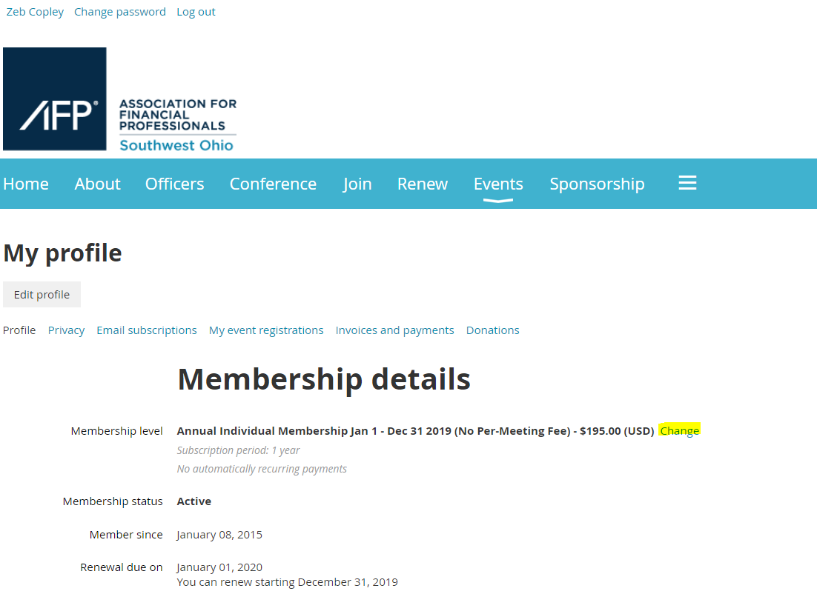
- Select the Membership Level you would like for 2020 and click “Next” in the bottom right hand corner.
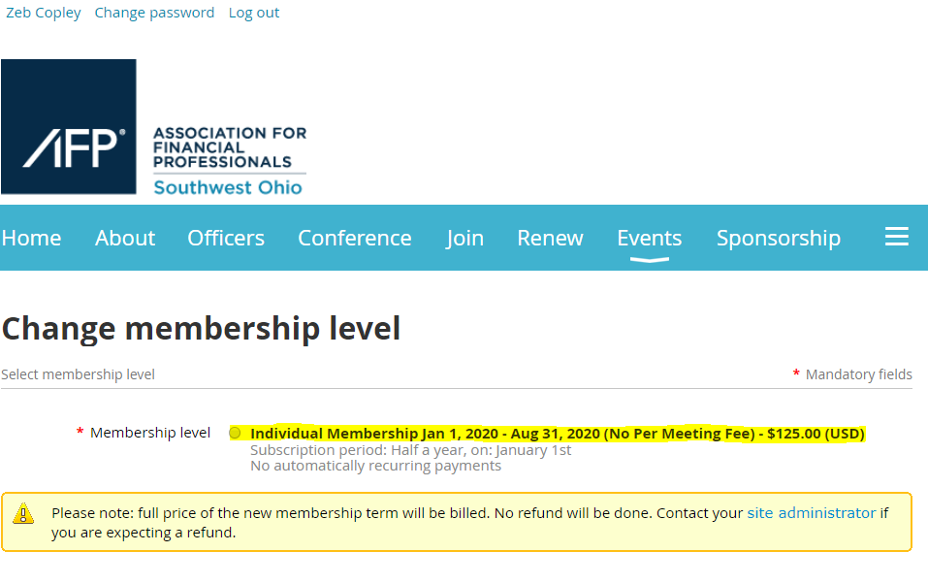
- Follow the prompts to update your contact information and submit your payment.

