Current Member? See below:
- Click the Login button in the top left-hand side of the page

- Enter your email address and password
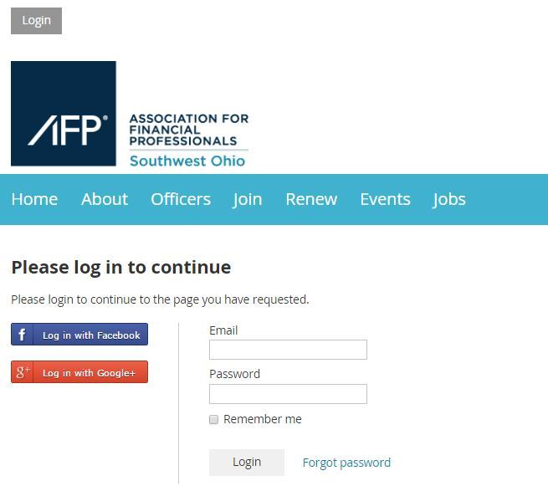

- Click on your name in the top left-hand side of the page
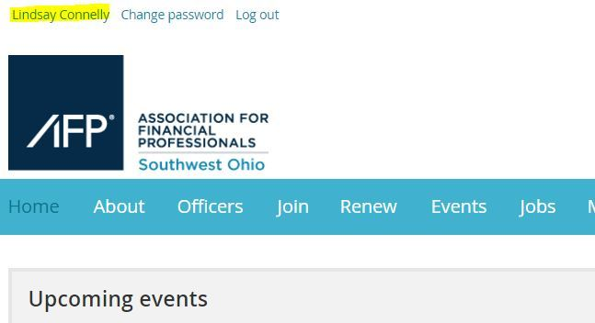

Click the button that says Renew until 01 Sep 2020

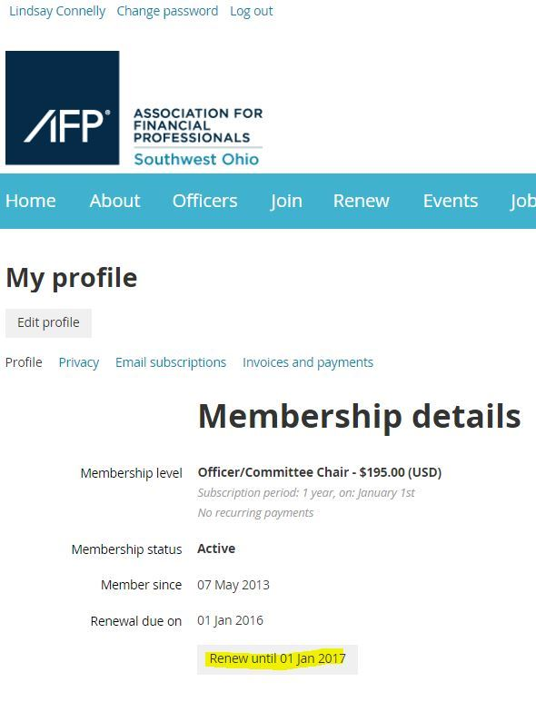
- Follow the prompts on the screen to process your payment

